# Emergency Fax

I am disabled

I cannot speak

I cannot hear

## 

***Who is sending this fax?***

### Name:________________________________ Your Fax Number:_____________________

***Where do you need help?***

### Street Address:____________________Apt./Room No.____________ Floor:_________

### City or location_ ____________________________________________________________

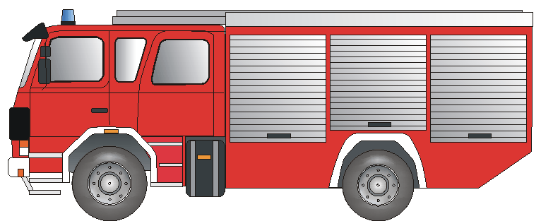***What kind of help?***

***What is happening?***

______________________________________________________________________________________________________________________________________________________________________________________________________________________________________

**Fire Department** Fire Rescue Accident



### **Ambulance** Paramedic Injury Illness

### 

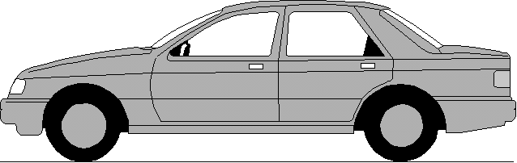

# **POLIZEI**

**Police**  Break-In/ Assault Violencei

#### *Thank you! Your Signature:_____________________________*

**Please fax back! Bitte zurückfaxen! Bitte zurückfaxen! Please fax back!**

##### We have received your emergency fax and ______________________________________________

***is on the way to your location.*** Signature of Receiving Dispatcher: _____________________________

Ein Service der BD Frankfurt am Main und dem Deutschen Schwerhörigenbund e. V. – Referat „Barrierefreies Planen und Bauen“/2011